**Lab#04**

**Object: To become familiar with rmi call back using primitive data types as arguments.**

**Task : Develop an RMI application for that handles the payroll and sends message back to client as an example of callback.**

1. **payrollInterface.java**

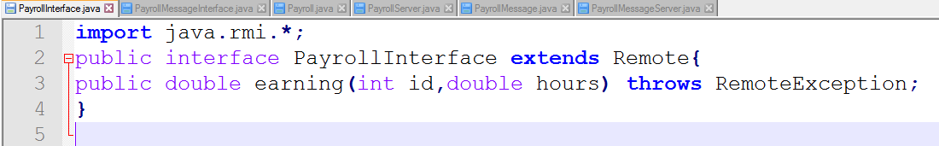

1. **payrollMessageIterface.java**

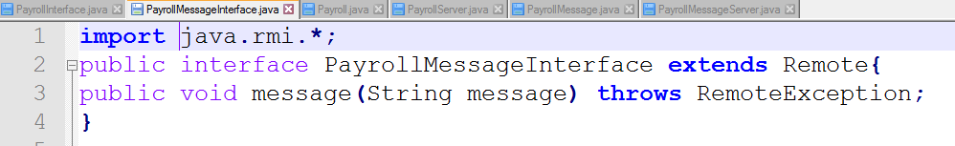

1. **payroll.java**

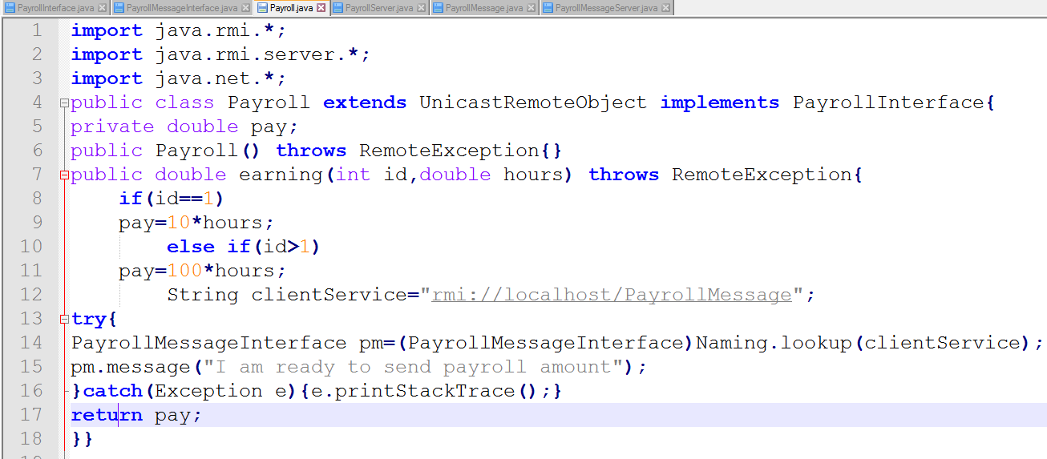

1. **payrollServer.java**

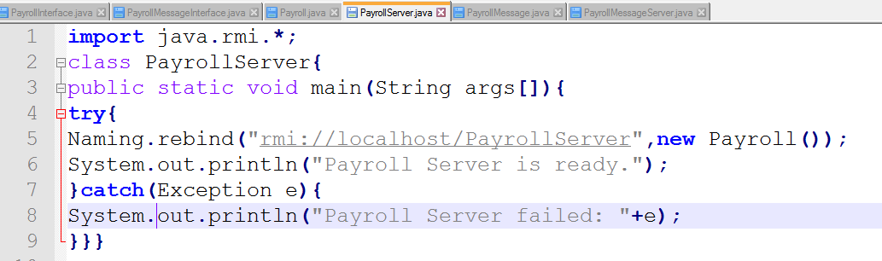

1. **payrollMessage.java**

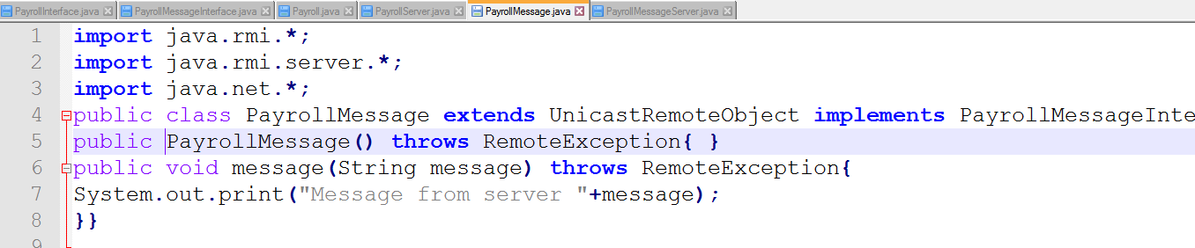

1. **payrollMessageServer.java**

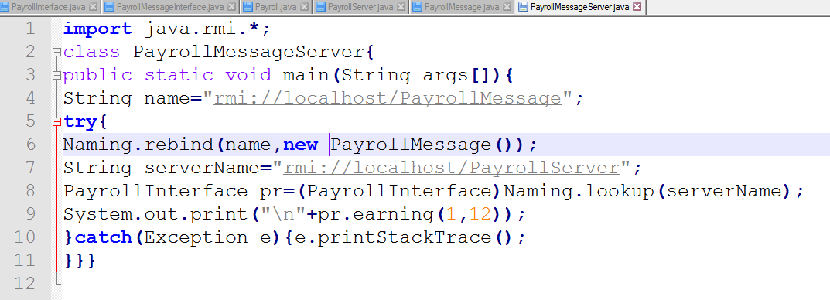

**Output:**



